**TOPIC-ReactJS-HOL**

**EXERCISE 1:**

import React from 'react';

function App() {

return (

<div>

<h1>Welcome to the first session of React</h1>

</div>

);

}

export default App;

**OUTPUT:**

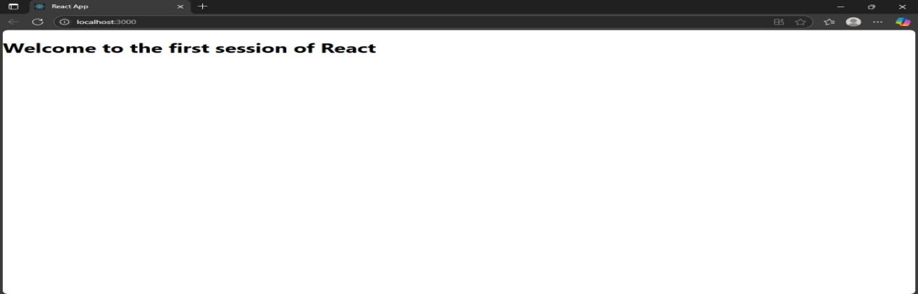

**Exercise 2:**

**Home.js:**

import React from 'react';

class Home extends React.Component {

render() {

return (

<div>

<h2>Welcome to the Home page of Student Management Portal</h2>

</div>

);

}

}

export default Home;

**About.js:**

import React from 'react';

class About extends React.Component {

render() {

return (

<div>

<h2>Welcome to the About page of the Student Management Portal</h2>

</div>

);

}

}

export default About;

**Contact.js:**

import React from 'react';

class Contact extends React.Component {

render() {

return (

<div>

<h2>Welcome to the Contact page of the Student Management Portal</h2>

</div>

);

}

}

export default Contact;

**App.js:**

import React from 'react';

import './App.css';

import Home from './Components/Home';

import About from './Components/About';

import Contact from './Components/Contact';

function App() {

return (

<div className="App">

<Home />

<About />

<Contact />

</div>

);

}

export default App;

**OUTPUT:**

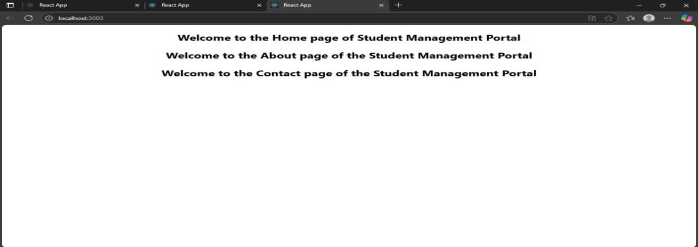

**Exercise 3:**

**CalculateScore.js:**

import React from 'react';

import '../Stylesheets/mystyle.css';

function CalculateScore(props) {

const average = props.total / props.goal;

return (

<div className="score-container">

<h2>Student Score Report</h2>

<p><strong>Name:</strong> {props.name}</p>

<p><strong>School:</strong> {props.school}</p>

<p><strong>Total Marks:</strong> {props.total}</p>

<p><strong>Goal:</strong> {props.goal}</p>

<p><strong>Average Score:</strong> {average.toFixed(2)}</p>

</div>

);

}

export default CalculateScore;

**mystyle.css:**

.score-container {

background-color: #f0f8ff;

border: 2px solid #007acc;

padding: 20px;

margin: 20px auto;

width: 50%;

border-radius: 10px;

font-family: Arial, sans-serif;

box-shadow: 0 0 10px rgba(0,0,0,0.1);

}

.score-container h2 {

color: #007acc;

text-align: center;

}

.score-container p {

font-size: 16px;

margin: 10px 0;

}

**App.js:**

import React from 'react';

import './App.css';

import CalculateScore from './Components/CalculateScore';

function App() {

return (

<div className="App">

<CalculateScore name="Sriswasthika" school="KRCE" total={450} goal={5} />

</div>

);

}

export default App;

**OUTPUT:**

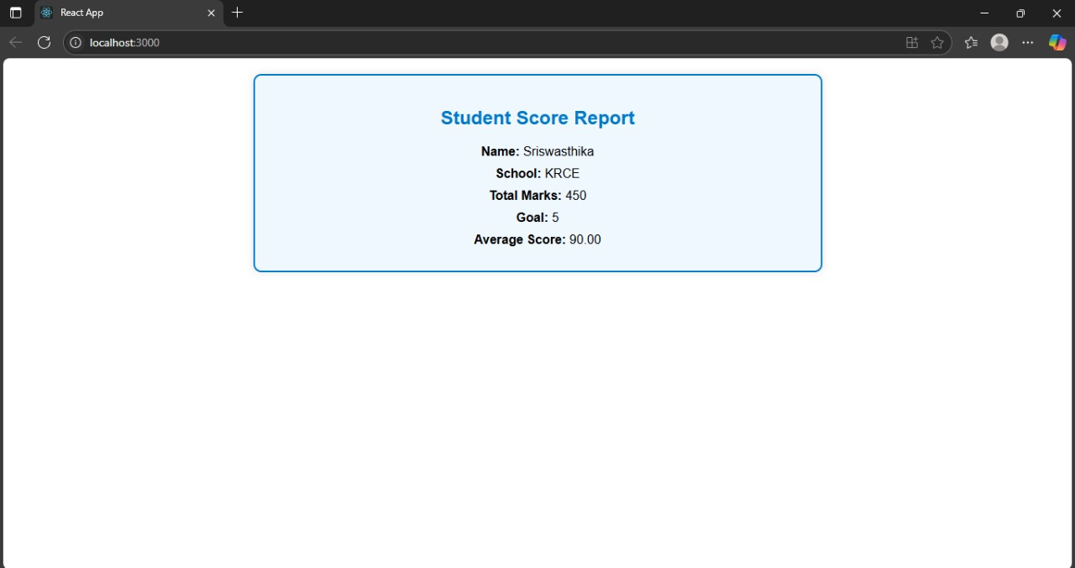

**Exercise 4:**

**post.js:**

import React from 'react';

class Post extends React.Component {

render() {

return (

<div>

<h2>{this.props.title}</h2>

<p>{this.props.body}</p>

</div>

);

}

}

export default Post;

**posts.js:**

import React, { Component } from 'react';

import Post from './Post';

class Posts extends Component {

constructor(props) {

super(props);

this.state = {

posts: [],

error: null,

};

}

loadPosts() {

fetch('https://jsonplaceholder.typicode.com/posts')

.then(response => {

if (!response.ok) throw new Error('Network response was not ok');

return response.json();

})

.then(data => this.setState({ posts: data }))

.catch(error => this.setState({ error }));

}

componentDidMount() {

this.loadPosts();

}

componentDidCatch(error, info) {

alert('An error occurred: ' + error);

}

render() {

const { posts, error } = this.state;

if (error) {

return <div>Error: {error.message}</div>;

}

return (

<div>

<h1>Blog Posts</h1>

{posts.slice(0, 10).map(post => (

<Post key={post.id} title={post.title} body={post.body} />

))}

</div>

);

}

}

export default Posts;

**app.js:**

import React from 'react';

import './App.css';

import Posts from './Posts';

function App() {

return (

<div className="App">

<Posts />

</div>

);

}

export default App;

**OUTPUT:**

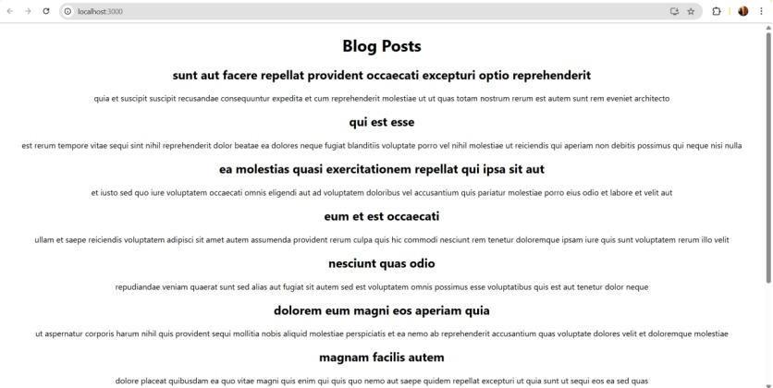

**Exercise 5::**

**App.js:**

import React from 'react';

import CohortDetails from './components/CohortDetails';

function App() {

const cohorts = [

{

id: 1,

name: 'React Bootcamp',

status: 'ongoing',

startDate: '2025-07-01',

endDate: '2025-09-01'

},

{

id: 2,

name: 'Java Spring Cohort',

status: 'completed',

startDate: '2025-04-01',

endDate: '2025-06-01'

}

];

return (

<div>

<h1>Cohort Dashboard</h1>

{cohorts.map((cohort) => (

<CohortDetails key={cohort.id} cohort={cohort} />

))}

</div>

);

}

export default App;

**CohortDetails.js:**

import React from 'react';

import styles from './CohortDetails.module.css';

function CohortDetails({ cohort }) {

return (

<div className={styles.box}>

<h3 style={{ color: cohort.status === 'ongoing' ? 'green' : 'blue' }}>

{cohort.name}

</h3>

<dl>

<dt>Status:</dt>

<dd>{cohort.status}</dd>

<dt>Start Date:</dt>

<dd>{cohort.startDate}</dd>

<dt>End Date:</dt>

<dd>{cohort.endDate}</dd>

</dl>

</div>

);

}

export default CohortDetails;

**CohortDetails.module.css:**

.box {

width: 300px;

display: inline-block;

margin: 10px;

padding: 10px 20px;

border: 1px solid black;

border-radius: 10px;

}

dt {

font-weight: 500;

}

**OUTPUT:**

